**WORKSHEET – Lab Equipment**

A number of items you will be using in the laboratory are shown below. Study this page and decide what the items may be used for, then, match the correct equipment pictured on this page to the tasks asked for on the other side of this paper.

Goggles



Lab Coat or

Apron

Graduated cylinder

Tongs

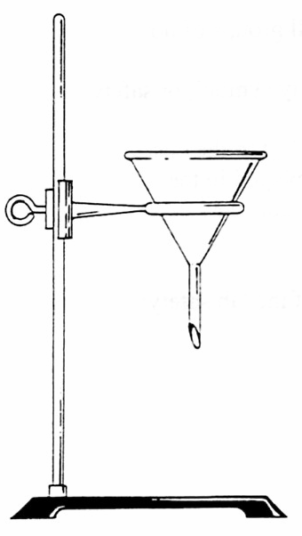

Triple Beam

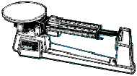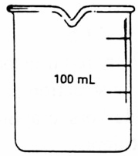

Balance

Lab Stand

Funnel

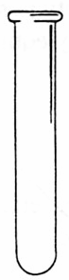

Ring Clamp

Test Tube Beaker

Striker

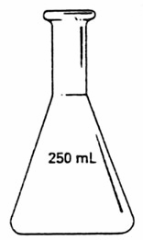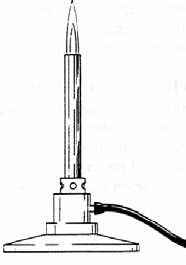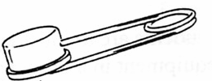

Bunsen burner

Erlenmeyer flask

Eye Dropper

|  |  |
| --- | --- |
| **Object Name** | **Used For** |
|  | Used to pick up or hold hot objects |
|  | Protects the eyes from flying objects or chemical splashes |
|  | A wide-mouthed container used to transport, heat or store substances |
|  | A small glass container used to view chemical reactions or to heat small amounts of a substance |
|  | A device to measure the mass or “mass out” and object or substance. |
|  | Protects the scientist and the scientist’s clothes from hazardous or hot chemicals |
|  | Used to dispense a very small amount of a liquid |
|  | Used to light a Bunsen burner |
|  | Attaches to a lab stand and used to hold a variety of lab equipment |
|  | Used to measure volume very precisely |
|  | Used to hold a variety of lab equipment |
|  | Used to pour liquids into containers with small openings or to hold filter paper |
|  | Used to heat objects |
|  | A narrow-mouthed container used to transport, heat or store substances, often used when a stopper is required |

**Write the correct abbreviation for each metric unit.**

1) Kilogram _____ 4) Milliliter _____ 7) Kilometer _____

2) Meter _____ 5) Millimeter _____ 8) Centimeter _____

3) Gram _____ 6) Liter _____ 9) Milligram _____

10. What instrument will we use to find the mass of objects? _________________________________

11. What would be the mass of the object measured in the picture? 

_______ + ______ + _______ = ________ g

11. The basic unit of length in the metric system in the _________________ and is represented by a lowercase ____.

Use the ruler and line below to answer the questions.



12. What is the length of the line in centimeters? _______cm

What is the length of the line in millimeters? _______mm

What is the length of the line to the nearest centimeter? ________cm