INSTRUCTION SHEET
TEACHER EVALUATION FORM

Student Outcome Data

To create a MEAP or MME Percent Proficient Trend Analysis Report in DataDirector, please follow these instructions:

Go to DataDirector from our website or enter: https://www98.achievedata.com/eup/

- Enter Username and Password
- Select the Site that you would like to work within
- Click the Reports tab
- Scroll down to the Pre-Built Reports
  - Click either MEAP Percent Proficient Trend Analysis or MME Percent Proficient Trend Analysis
- Click bubble Year To Year Comparison
- Click Add Test Year(s)
  - Hold CTRL + Three most recent years
  - Click Save Changes
- Click Submit at bottom of page
- Click the down arrow under Available Subjects, Choose appropriate curriculum and grade

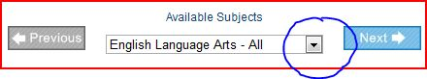

Copying and Pasting
Copy and paste the graph from DataDirector into the following picture control:
- Insertion point must be on graph in DataDirector
- Right Click, Copy
- Go back to Microsoft® Word-Teacher Evaluation Template
- Click on Picture Control (blue box), Right Click, Paste

Evidence of Professional Growth
Instruction (Administrator)

Log into the MRX web site: https://mxweb.media-x.com/home/mcrel/

- Click on:

- To the right of Walkthrough tab, click Reports

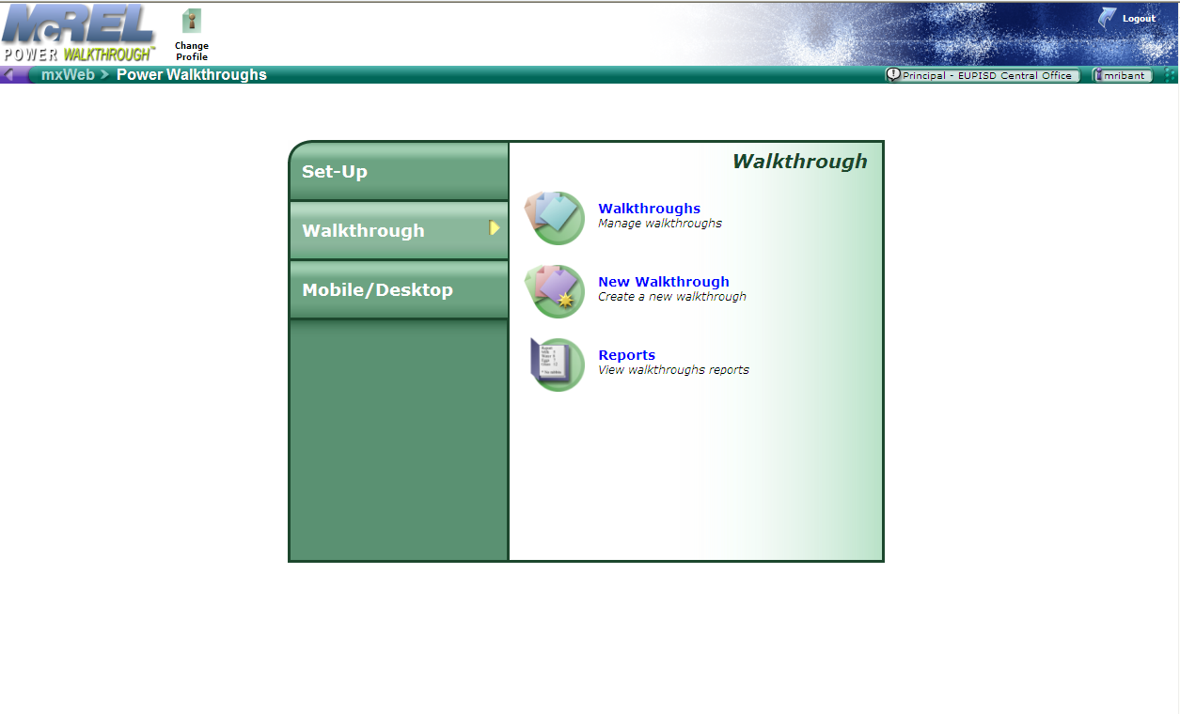

- Click on the Report type(s) to include in the evaluation – See below
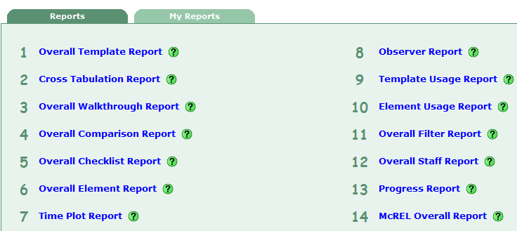

Setup perimeters accordingly (see primary strategies report below)

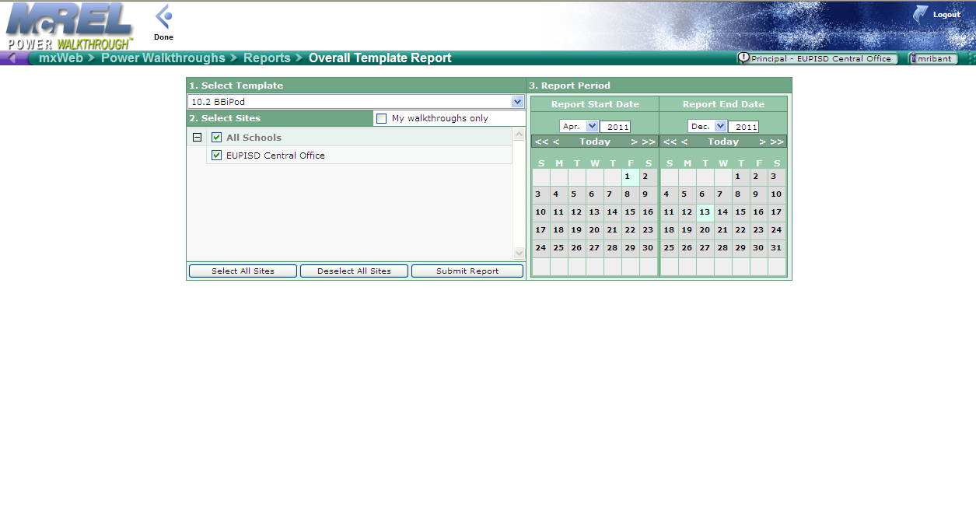

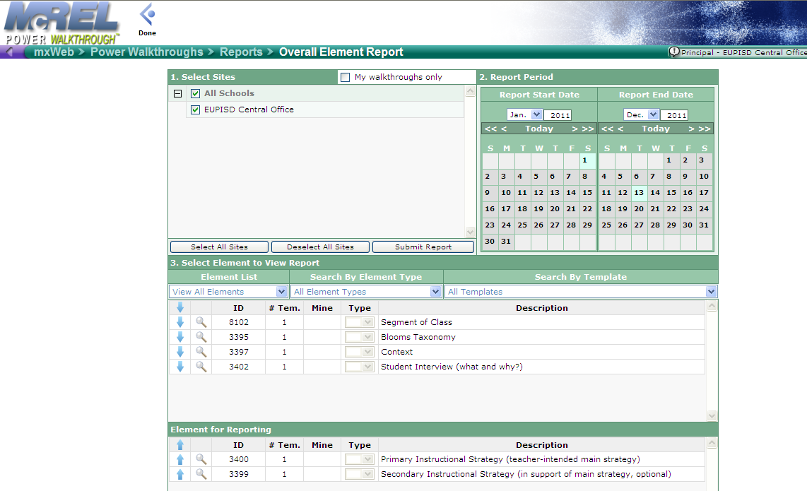

Use the snipping tool of your choice so you can copy and paste to the Teacher Evaluation form.
We recommend using “Jing”
- http://www.techsmith.com/jing
- Free Version

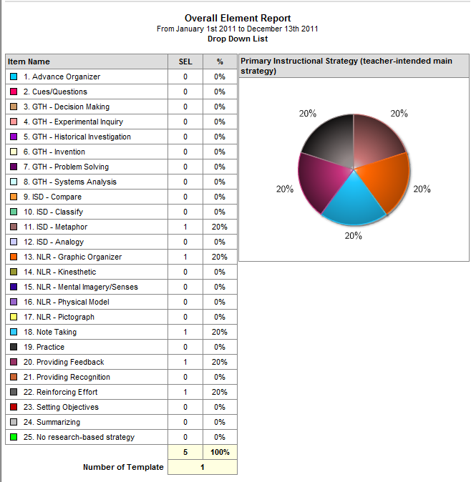

Include as many of the reports that are relevant to the evaluation. Delete any Picture Controls (blue boxes) that are not needed on the Teacher Evaluation form.

